Performance Settings
- Log into your site dashboard
- Using the top menu bar, hover over the Advanced Parameters tab and click on the Performance option from the menu.
- Config Smarty

- Config CCC (Combine, Compress and Cache)
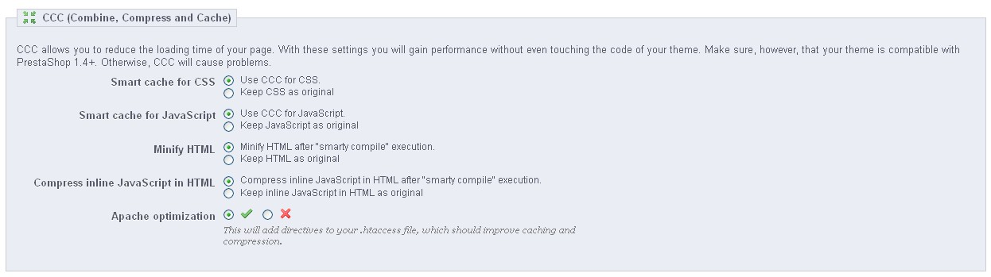
- Caching
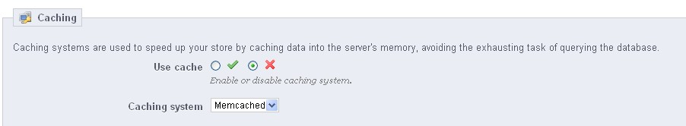
Note:
Reference link:
http://presthemes.com/prestashop-news/10-best-tips-to-speed-up-your-prestashop-store-57.html

